1.How are inline and block elements different from each other?

Ans: An inline element does not cause a line break means it will not start on a new line and does not take up the full width of a page,only the space bounded by its opening and closing tag.It is usually used within other HTML elements.Examples are:

1. Anchor <a> tag
2. Image <img> tag
3. Bold <b> tag

A block-level element always starts on a new line and takes up the full width of a page from left to right.Examples are:

1. Heading tags <h1> to <h6>
2. Ordered,Unordered List and List Item tags <ol>,<ul>,<li>
3. Pre -formatted text tag <pre>

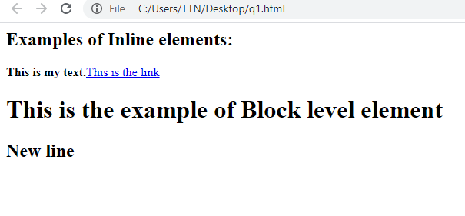

2.Explain the difference between visibility:hidden and display:none

display:none:-means that the tag in question will not appear on the page at all and there will be no space allocated for it between the other tags.

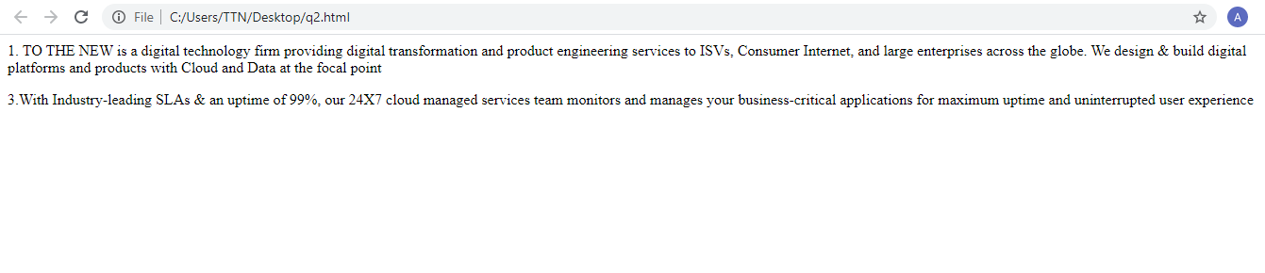

visibility:hidden:-means that the tag is not visible, but space is allocated for it on the page. when the tag is rendered, it just isn't seen on the page.

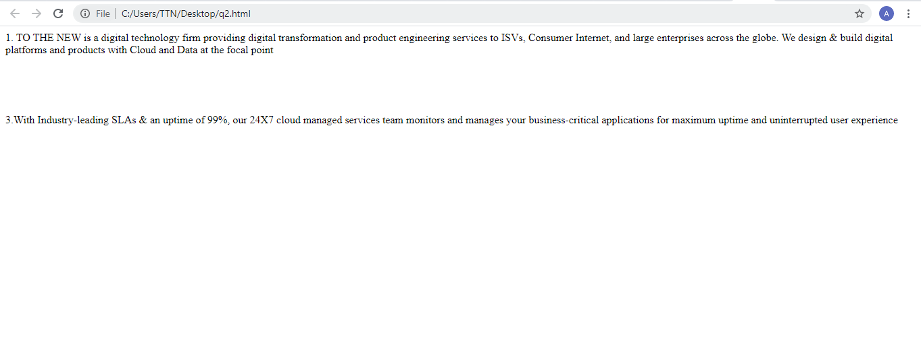

3. Explain the clear and float properties.

Ans: Float:

a)Specifies how an element should float.

b)Used for positioning and formatting content e.g. let an image float left to the text in a container.

c) The float property can have one of the following values:

* left - The element floats to the left of its container
* right - The element floats to the right of its container
* none - The element does not float (will be displayed just where it occurs in the text). This is default
* inherit - The element inherits the float value of its parent

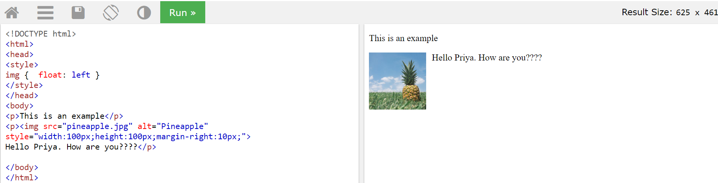

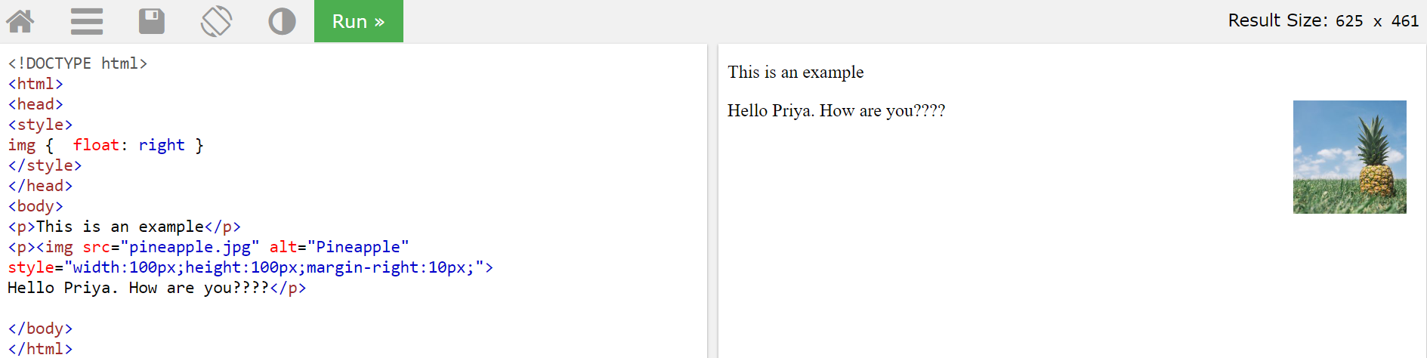

Clear:

a)Specifies what elements can float beside the cleared element and on which side.

b)The clear property can have one of the following values:

* none - Allows floating elements on both sides. This is default
* left - No floating elements allowed on the left side
* right- No floating elements allowed on the right side
* both - No floating elements allowed on either the left or the right side
* inherit - The element inherits the clear value of its parent

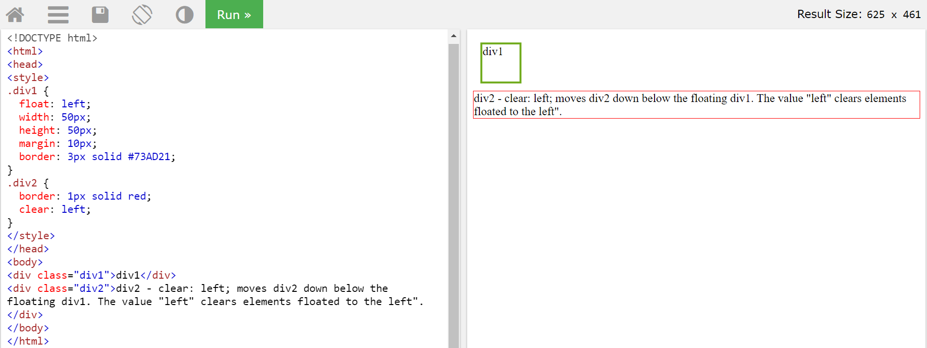

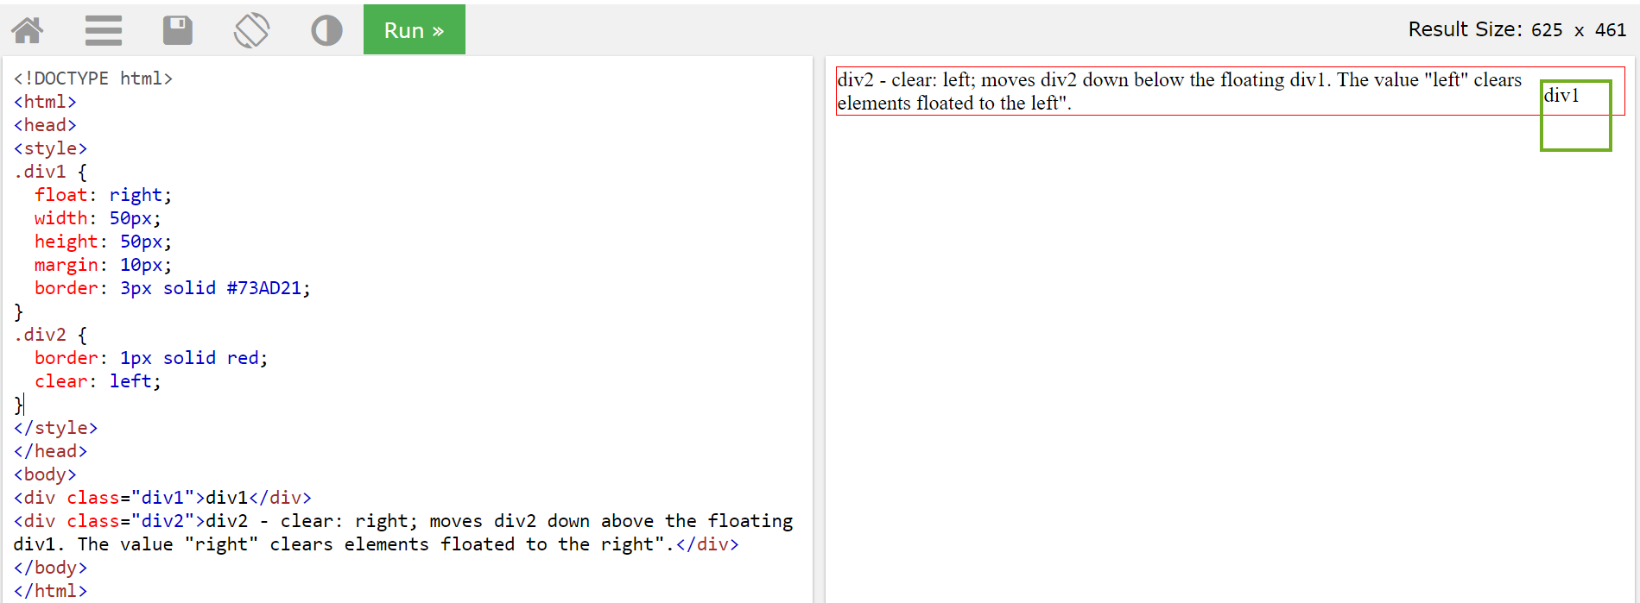

4. Explain the difference between absolute, relative,fixed and static.

Ans: The position property specifies the type of positioning method used for an element.There are different position values:

* static
* relative
* fixed
* absolute

##### 

##### 

Position:**Static**:-

Static positioned elements are not affected by the top , bottom , left and right properties. An element with position: static and is not positioned in any special way.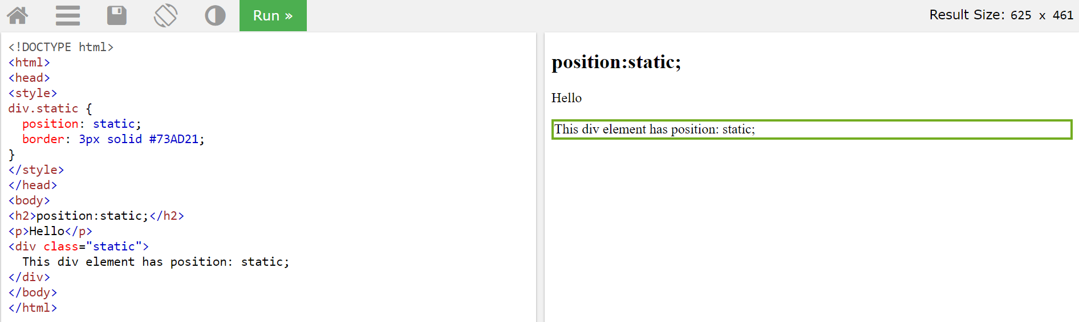

Position: **Relative**:-

An element with position: relative is positioned relative to its normal position.Setting the top, right, bottom, and left properties of a relatively-positioned element will cause it to be adjusted away from its normal position. Other content will not be adjusted to fit into any gap left by the element.This <div> element has position: relative.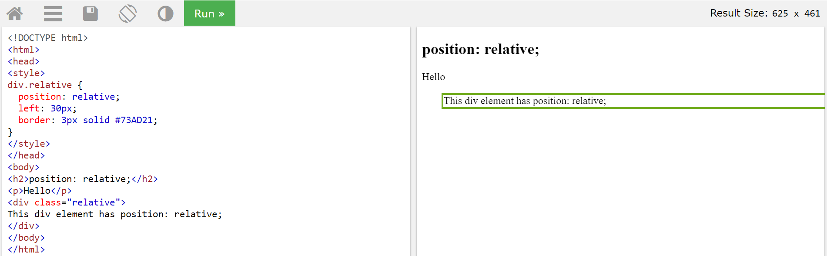

Position:**Absolute**:-

An element with position: absolute is positioned relative to the nearest positioned ancestor and if an absolute positioned element has no positioned ancestors, it uses the document body, and moves along with page scrolling.

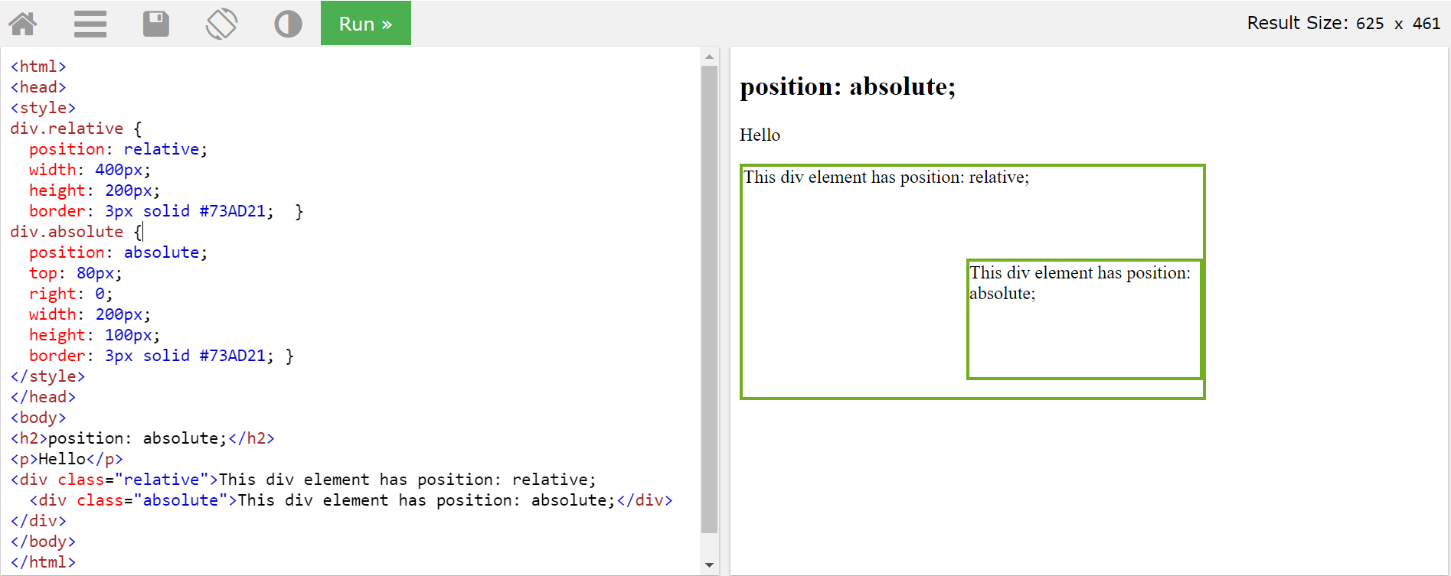

Position:**Fixed**:-

An element with position: fixed is positioned relative to the viewport, which means it always stays in the same place even if the page is scrolled. The top, right, bottom, and left properties are used to position the element.A fixed element does not leave a gap in the page where it would normally have been located.

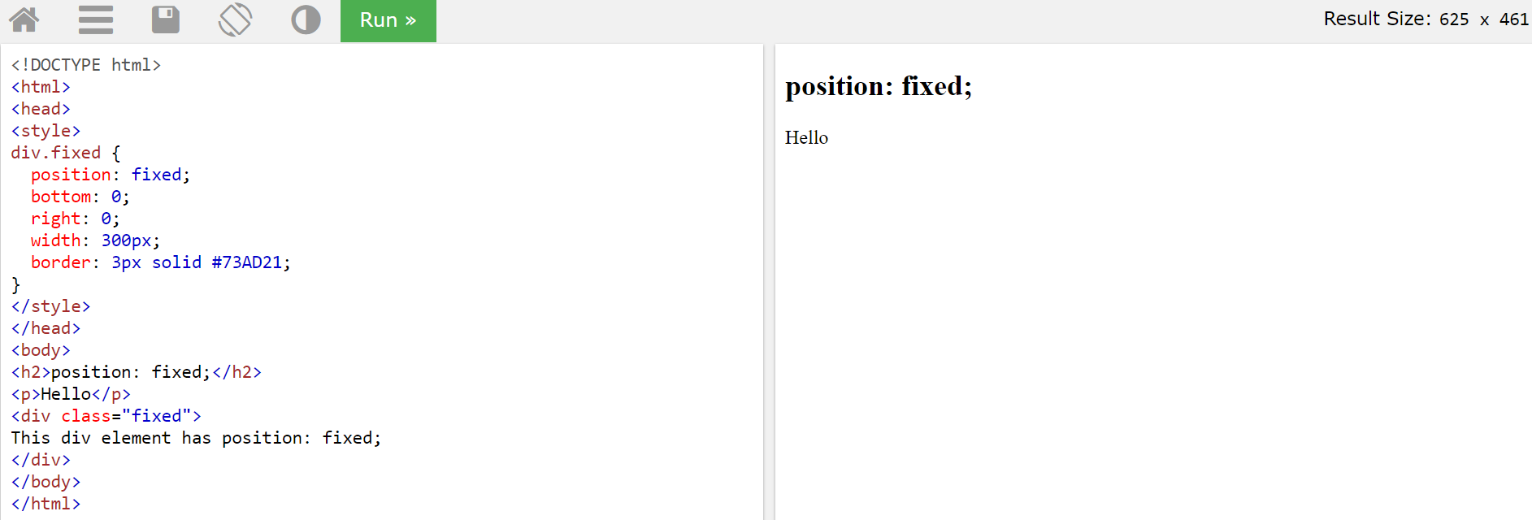

5. Write the HTML code to create a table in which there are 4 columns( ID , Employee Name, Designation, Department) and at least 6 rows. Also do some styling to it.

Table.html

<html>

<had><title>Table</title>

<meta name="viewport" content="width=device-width, initial-scale=1.0">

<link rel="stylesheet" href="style.css">

</had>

<body>

<div class="table-box">

<div class="table-row table-head">

<div class="table-cell first-cell">

<p>Employee ID</p>

</div>

<div class="table-cell">

<p>Employee Name</p>

</div>

<div class="table-cell last-cell">

<p>Designation</p>

</div>

<div class="table-cell last-cell">

<p>Department</p>

</div>

</div>

<div class="table-row">

<div class="table-cell first-cell">

<p>101</p>

</div>

<div class="table-cell ">

<p>Anam</p>

</div>

<div class="table-cell">

<p>Trainee</p>

</div>

<div class="table-cell">

<p>QE</p>

</div>

</div>

<div class="table-row">

<div class="table-cell first-cell">

<p>101</p>

</div>

<div class="table-cell ">

<p>Mansi</p>

</div>

<div class="table-cell">

<p>Trainee</p>

</div>

<div class="table-cell">

<p>DevOps</p>

</div>

</div>

<div class="table-row">

<div class="table-cell first-cell">

<p>101</p>

</div>

<div class="table-cell ">

<p>Shama</p>

</div>

<div class="table-cell">

<p>Trainee</p>

</div>

<div class="table-cell">

<p>IOS</p>

</div>

</div>

<div class="table-row">

<div class="table-cell first-cell">

<p>101</p>

</div>

<div class="table-cell ">

<p>Faizi</p>

</div>

<div class="table-cell">

<p>Trainee</p>

</div>

<div class="table-cell">

<p>Jvm</p>

</div>

</div>

<div class="table-row">

<div class="table-cell first-cell">

<p>101</p>

</div>

<div class="table-cell ">

<p>Himani</p>

</div>

<div class="table-cell">

<p>Trainee</p>

</div>

<div class="table-cell">

<p>MEAN</p>

</div>

</div> <div class="table-row">

<div class="table-cell first-cell">

<p>101</p>

</div>

<div class="table-cell ">

<p>Shivani</p>

</div>

<div class="table-cell">

<p>Trainee</p>

</div>

<div class="table-cell">

<p>FEEN</p>

</div>

</div></div>

</body>

</html>

Table.css

*{

margin: 0;

padding: 0;

}

.table-box

{

margin: 50px auto;

}

.table-row{

display: table;

width: 80%;

margin: 10px auto;

font-family: sans-serif;

background: transparent;

padding: 12px 0;

color: #555;

font-size: 13px;

box-shadow: 0 1px 4px 0px rgba(0,0,50,0.3);

}

.table-head{

background: #8665f7;

box-shadow: none;

color: #fff;

font-weight: 600;

}

.table-head .table-cell{

border-right: none;

}

.table-cell{

display: table-cell;

width: 20%;

text-align: center;

padding: 4px 0;

border-right: 1px solid #d6d4d4;

vertical-align: middle;

}

.first-cell{

text-align: left;

padding-left: 10px;

}

.last-cell{

border-right: none;

}

a{

text-decoration: none;

color: #555;

}

@media only screen and (max-width: 600px) {

.table-row {

font-size: 11px;

}

}

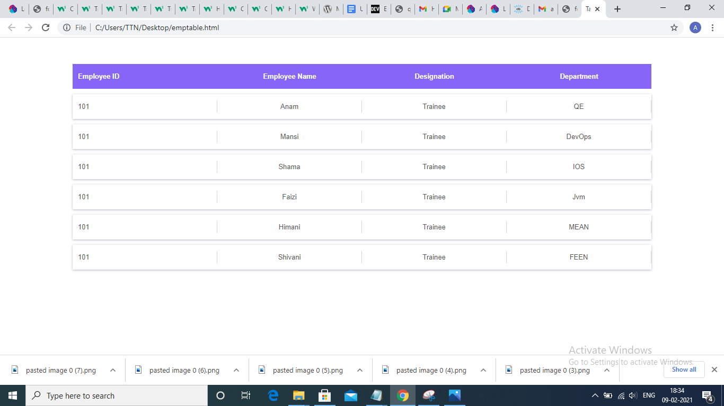

6. Why do we use meta tags?

a)Metadata is data (information) about data.

b)<meta> tag defines metadata about an HTML document.

c)<meta> tags always go inside the <head> element, and are typically used to specify character set, page description, keywords, author of the document, and viewport settings.

d)You can include one or more meta tags in your document based on what information you want to keep in your document.

e)Meta tags are important because they impact how your site appears and how many people will be inclined to click through to your website.

f)Meta tags are the words that are hidden in your code. People browsing your site will just not be able to see them.

7. Explain box model.

a)CSS box model is a container which contains multiple properties including borders, margin, padding and the content itself.

b)It is used to create the design and layout of web pages.

c)It can be used as a toolkit for customizing the layout of different elements.

d)The web browser renders every element as a rectangular box according to the CSS box model.

e)The CSS box model is a box that wraps around every HTML element.

f) Properties are :

Content - The content of the box, where text and images appear

Padding - Clears an area around the content. The padding is transparent

Border - A border that goes around the padding and content

Margin - Clears an area outside the border. The margin is transparent

g)The box model allows us to add a border around elements and to define space between elements.

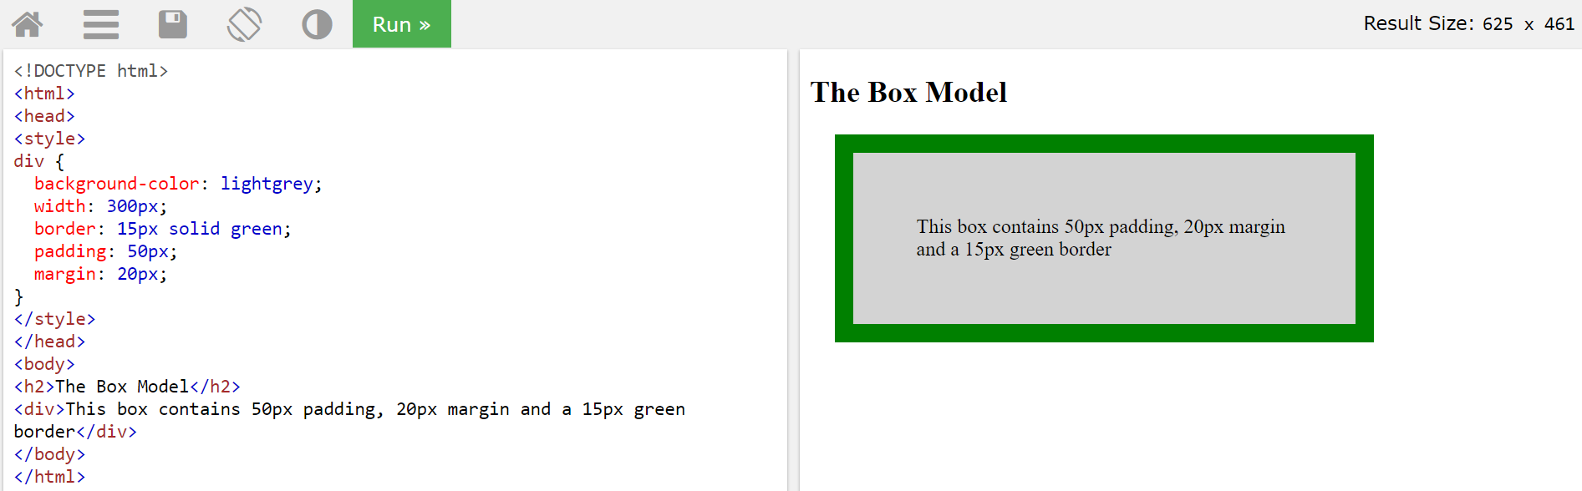

8. What are the different types of CSS Selectors?

Ans;CSS Selector used to select the content you want to style and the types of CSS Selectors are:

a)CSS Element Selector:The element selector selects the HTML element by name.

b)CSS Id Selector:id selector selects the id attribute of an HTML element to select a specific element and id is always unique within the page so it is chosen to select a single, unique element.

c)CSS Class Selector:it selects HTML elements with a specific class attribute and It is used with a period character . (full stop symbol) followed by the class name

d)CSS Class Selector form specific element:If we want to specify that only one specific HTML element should be affected then we should use the element name with class selector.

e)CSS Universal Selector:it is used as a wildcard character and it selects all the elements on the pages.

f)CSS group Selector:it is used to select all the elements with the same style definitions and it is used to minimize the code and we can use commas to separate each selector in grouping.

9. Define Doctype.

ANS: a)Doctype stands for Document Type Declaration

b)It is also called as document type declaration (DTD).

c)All HTML documents must start with a <!DOCTYPE> declaration.

d)It informs the web browser about the type and version of HTML used in building the web document.

e)It helps the browser to handle and load it properly.

f)The <!DOCTYPE> declaration is NOT case sensitive.

g)It is a null element which does not contain the closing tag, and must not include any content within it.

10. Explain 5 HTML5 semantic tags.

Ans: 1) <article>

a)The <article> element specifies independent, self-contained content.

b)An article should make sense on its own, and it should be possible to read it independently from the rest of the web site.Examples:Newspaper article,Blog post.

2)<header>

a)The <header> element specifies a header for a document or section.

b)The <header> element should be used as a container for introductory content.

3)<footer>

a)The <footer> element specifies a footer for a document or section.

b)A <footer> element should contain information about its containing element.

4) <nav>

a)The <nav> element defines a set of navigation links.

b)The <nav> element is used for large blocks of navigation links

5) <aside>

a)The <aside> element defines some content aside from the content it is placed in (like a sidebar).

11. Create HTML for web-page.jpg

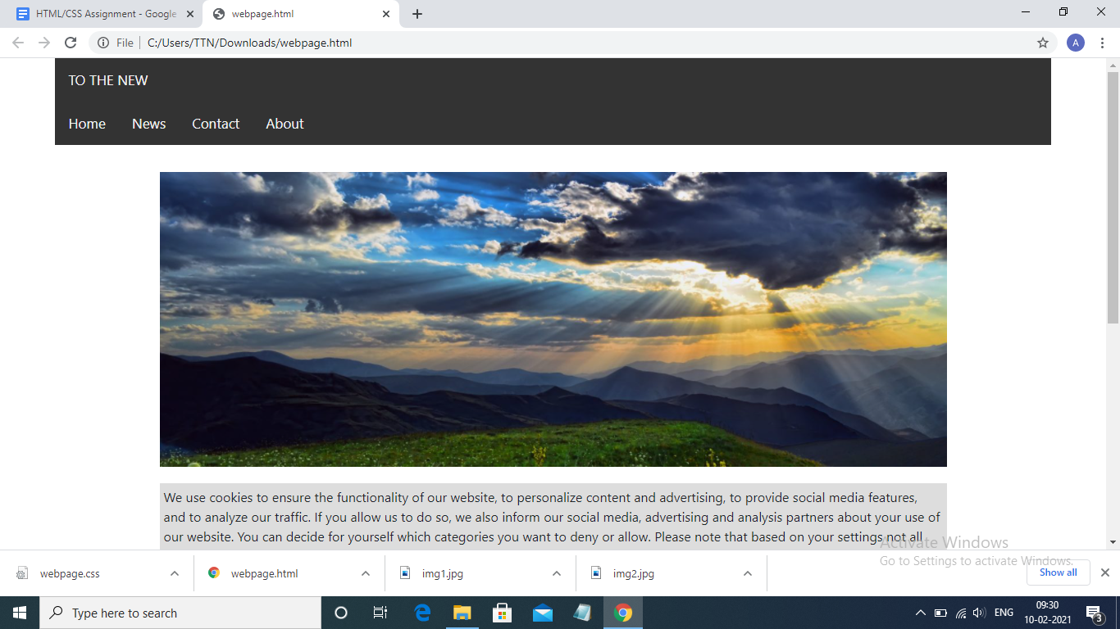

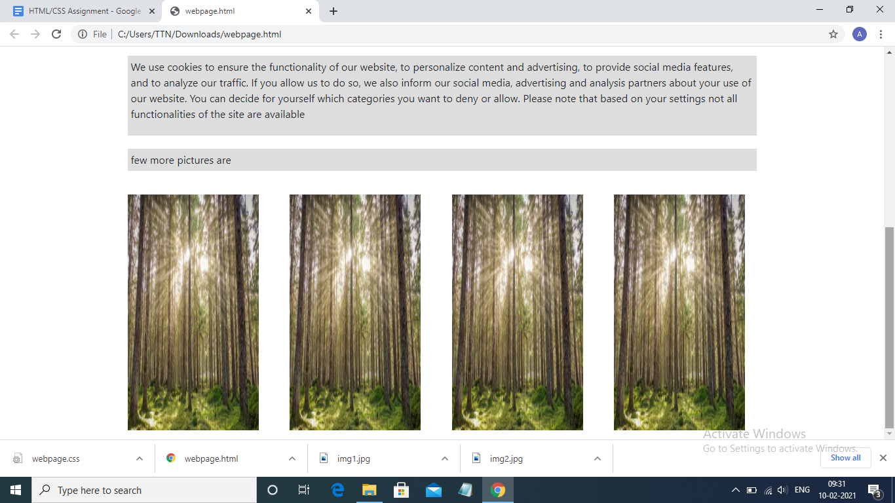

Webpage.html:

<html>

<head>

<title></title>

<link rel="stylesheet" type="text/css" href="webpage.css">

<link rel="stylesheet" href="https://maxcdn.bootstrapcdn.com/bootstrap/4.0.0/css/bootstrap.min.css" integrity="sha384-Gn5384xqQ1aoWXA+058RXPxPg6fy4IWvTNh0E263XmFcJlSAwiGgFAW/dAiS6JXm" crossorigin="anonymous">

</head>

<body>

<div class="topnav">

<a class="navbar-brand" href="#">TO THE NEW</a>

</div>

<div class="topnav">

<a class="active" href="#home">Home</a>

<a href="#news">News</a>

<a href="#contact">Contact</a>

<a href="#about">About</a>

</div>

<div class="content">

<img id="setImg1" src="img1.jpg">

<div class="para">

<p >We use cookies to ensure the functionality of our website, to personalize content and advertising, to provide social media features, and to analyze our traffic. If you allow us to do so, we also inform our social media, advertising and analysis partners about your use of our website. You can decide for yourself which categories you want to deny or allow. Please note that based on your settings not all functionalities of the site are available</p>

</div>

<p class="para">few more pictures are</p>

<div class="fixSize">

<div class="row">

<div class="col"><img id="setImg2" src="img2.jpg"></div>

<div class="col"><img id="setImg2"src="img2.jpg"></div>

<div class="col"><img id="setImg2" src="img2.jpg"></div>

<div class="col"><img id="setImg2" src="img2.jpg"></div>

</div>

</div>

</div>

</body>

</html>

Webpage.css

.topnav {

background-color: #333;

overflow: hidden;

margin-left: 5%;

margin-right:5%;

}

.topnav a {

float: left;

color: #f2f2f2;

text-align: center;

padding: 14px 16px;

text-decoration: none;

font-size: 17px;

}

.topnav a:hover {

background-color: #ddd;

color: black;

}

html { background-color: black; }

body{

margin:50px;

background-color: black;

}

.content{

background-color: white;

margin-left: 5%;

margin-right:5%;

padding: 1%;

}

#setImg1{

height: 360px;

width: 960px;

display: block;

margin-left: auto;

margin-right: auto;

margin-top: 20px;

}

#setImg2{

height: 360px;

width: 200px;

margin-top: 20px;

}

.para{

background-color: #ddd;

display: block;

margin-left: auto;

margin-right: auto;

width: 960px;

padding: 5px;

margin-top: 20px;

}

.fixSize{

width: 960px;

display: block;

margin-left: auto;

margin-right: auto;

}

12. Create HTML for form.png

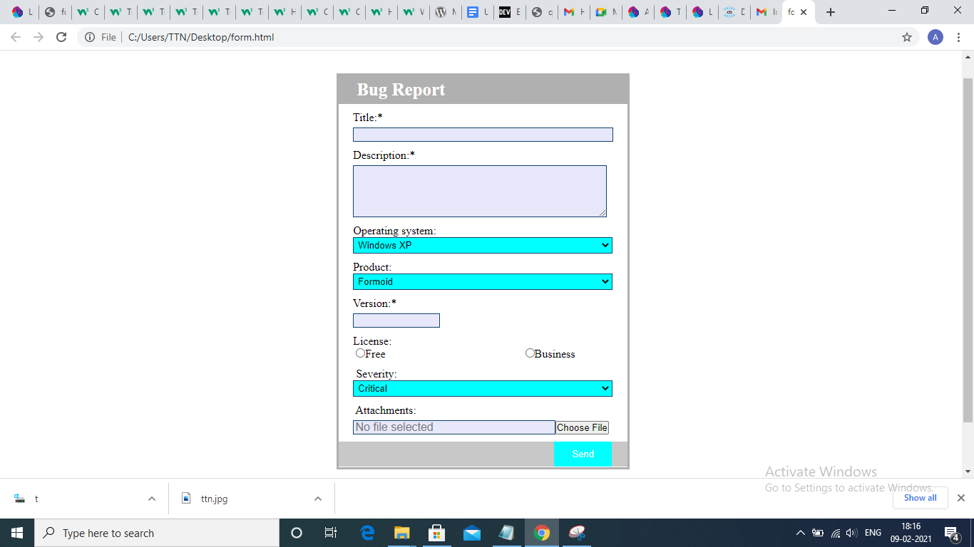

Form.html:

<html >

<head>

<meta charset="UTF-8">

<meta name="viewport" content="width=device-width, initial-scale=1.0">

<title>form</title>

<link href="form.css" rel="stylesheet">

</head>

<body><p>

<h3>TO <a href="url">Home</a><a href="url">Quick help</a>

<div class="warpper fl">

<div class="main">

<div class="head"><p>&nbsp;&nbsp;&nbsp;&nbsp;Bug Report</p>

</div>

<div class="form fl">

<form method="POST">

<p class="name"><p>

&nbsp;&nbsp; &nbsp; Title:*<input type="text" name="fname" class="name-inp"></p>

<p class="name"><p>

&nbsp;&nbsp; &nbsp; Description:*<textarea name="fname" class="name-inp" rows="4" cols="50"></textarea>

<p class="name"><p>

&nbsp;&nbsp; &nbsp; Operating system:

<p>&nbsp;&nbsp; &nbsp;&nbsp;<select class="os" >

<option value="Windows XP">Windows XP</option>

<option value="linux">Linux</option>

</select>

<p class="name"><p>

&nbsp;&nbsp; &nbsp; Product:

<p>&nbsp;&nbsp; &nbsp;&nbsp;<select class="os" >

<option value="Formoid">Formoid</option>

<option value="form name">Form name</option>

</select>

<p class="name"><p>

&nbsp;&nbsp; &nbsp; Version:*<p><input type="text" name="version" class="ver"></p>

<p class="name">

<p>

&nbsp;&nbsp;&nbsp;&nbsp; License:<br>

&nbsp;&nbsp; &nbsp;&nbsp;&nbsp;<input type="radio" name="free" value="Free">Free

; <input type="radio" name="business" value="Business">Business

<p class="name">

<p>

&nbsp;&nbsp; &nbsp;&nbsp; Severity:

<p>&nbsp;&nbsp; &nbsp;&nbsp;<select class="os" >

<option value="Critical">Critical</option>

<option value="non-critical">Non-critical</option>

</select>

<p class="name">

<p>

&nbsp;&nbsp; &nbsp;&nbsp; Attachments:

<p>

<input type="text" name="fname" placeholder="No file selected" class="attach"><input type="submit" value="Choose File"></p>

<p class="name">

<div class="footer">

<input type="submit" value="Send" class="send">

</div>

</form>

</div>

</div></div></body></html>

Form.css:

*{

margin: 0;

padding: 0;

}

.fl{

float: left;

}

.wrapper{

width: 100%;

height: 100vh;

background-image: url("image/a3.png");

background-repeat: no-repeat;

background-size: cover;

}

.main{

width: 30%;

height: 550px;

background-color: #FFFFFF;

margin: 60px 35%;

border-bottom-left-right-radius: 25px;

border-style: solid;

border-color: #B0B0B0;

border-width: medium;

}

.head{

width: 100%;

background-color: #B0B0B0;

height: 40px; border-radius: 10 10 10 10;}

.head p{

line-height: 40px;

text-align: left;

font-size: 25px;

font-weight: bold;

color: #fff;

}

.form{

width: 100%;

height: 600px;

}

.name{

font-size: 16px;

color: #fff;

margin: 10px 0 0 5%;

}

.name-inp{

width: 90%;

height: 20px;

margin: 5px 0 0 5%;

font-size: 16px;

padding: 2px;

color: rgb(0,0,0);

border: 1px solid rgb(17, 67, 107);

border-style: ridge;

background-color: rgb(231, 232, 250);

}

.name-inp:hover{

background-color: rgb(0, 0, 0);

color: rgb(173, 167, 167);

border: 1px solid rgb(139, 139, 139);

}

.pass{

margin: 5px 0 0 5%;

height: 20px;

width: 41%;

padding: 2px;

background-color: rgb(231, 232, 250);

border-style: ridge;

}

.os{

margin: 15px 0 0 5%

height:20px;

width: 90%;

padding: 2px;

background-color:#00FFFF;

border-style: ridge;

border: 1px solid;

border: 1px solid rgb(17, 67, 107);

}

.attach{

width:70%;

height: 20px;

margin: 5px 0 0 5%;

font-size: 16px;

padding: 2px;

color: rgb(114, 111, 111);

border: 1px solid rgb(17, 67, 107);

background-color: rgb(231, 232, 250);

border-style: ridge}

.pass:hover{

background-color: rgb(0, 23, 41);

color: rgb(173, 167, 167);

border: 1px solid rgb(139, 139, 139);

}

.gender{

margin: 15px 0 0 5%;

color: #fff;

font-size: 16px;

}

.gen{

font-size: 18px;

}

.genm{

margin-left: 5%;

}

.sub{

width: 90%;

margin: 15px 0 0 5%;

font-size: 16px;

height: 40px;

background-color: #031c30;

border: 1px solid rgb(17, 67, 107);

color: #fff;

}

.sub:hover{

background-color: #E94601;

color: #fff;

}

.ver{

width: 30%;

height: 20px;

margin: 5px 0 0 5%;

font-size: 16px;

padding: 2px;

color: rgb(114, 111, 111);

border: 1px solid rgb(17, 67, 107);

background-color: rgb(231, 232, 250);

}

.send{

background-color:#00FFFF;

border: none;

color: white;

padding: 10px 10px;

text-align: center;

text-decoration: none;

display: inline-block;

font-size: 13px;

border: 1px solid;

}

.a{

text-decoration:none;

}

.footer {

position:middle;

left: 5;

bottom: 5;

width: 100%;

background-color: #C8C8C8;

color: white;

text-align: center;

}

.h1 {

color: #00ff00;

}